**Medical Image Classification using Convolutional Neural**

**Network (CNN)**

Project submitted to the

SRM University – AP, Andhra Pradesh

for the partial fulfillment of the requirements to award the degree of

**Bachelor of Technology**

In

**Computer Science and Engineering**

**School of Engineering and Sciences**

Submitted by

**Krishna Mihir Tatavarthi**

**(AP20110010510)**



Under the Guidance of

**(Dr. Ajay Bhardwaj)**

**SRM University–AP**

**Neerukonda, Mangalagiri, Guntur**

**Andhra Pradesh – 522 240**

**[December, 2022]**

# Certificate

Date: 14-Dec-22

This is to certify that the work present in this Project entitled “**Medical Image Classification using Convolutional Neural Network**” has been carried out by Krishna Mihir Tatavarthi under supervision of Dr. Ajay Bhardwaj. The work is genuine, original, and suitable for submission to the SRM University – AP for the award of Bachelor of Technology in **School of Engineering and Sciences**.

### Supervisor

(Signature)

Dr. Ajay Bhardwaj

Associate Professor,

Department of COMPUTER SCIENCE AND ENGINEERING,

SRM University – AP, Andhra Pradesh

# Acknowledgements

I would like to express my heartfelt gratitude to everyone who made this project possible. I am especially grateful to my Project Supervisor for support me throughout and stimulating suggestions, encouragement and guidance assisted to me in coordinating my project.

# Table of Contents

Certificate .................................................................................................................................. i

Acknowledgements .............................................................................................................. iii

Table of Contents .................................................................................................................... v

Abstract.................................................................................................................................. vii

Abbreviations ....................................................................................................................... iix List of Figures ......................................................................................................................... xi

1. Introduction ..................................................................................................................... 1
2. Literature Review ............................................................................................................ 4
3. Methodology .................................................................................................................. 28
4. Simulation ..................................................................................................................... 33
5. Conclusion Remarks ..................................................................................................... 38
6. Future Work ................................................................................................................... 40

References .............................................................................................................................. 42

# Abstract

More than a million people die every year because of various lung diseases like pneumonia, lung cancer, COVID 19 etc. Lung diseases can affect respiratory functions or the ability to breathe. Lung’s diseases can be viral, bacterial, or fungal in nature. It can sometimes be a life-threatening disease which can result in the death of a human being. World health organization (WHO) has reported that one out of three deaths in India is caused due to pneumonia, which is why analysis and classification of these lung diseases has become an important matter to investigate. As a result, we do require a method with high accuracy for classification and detection of lung diseases because of the increasing number of cases in recent times. Convolutional Neural Networks (CNN) has gained a lot of popularity in the recent times because of its accuracy in image classification. In this study we have proposed a model using Convolutional Neural Networks (CNN) architectures for detection of pneumonia and COVID 19. Chest X-ray images are used for classification and detection of the diseases. By using this model, we have managed to achieve an accuracy of 90% for pneumonia and 95% for COVID-19.

# Abbreviations

|  |  |  |
| --- | --- | --- |
| AD |  | Anaerobic Digestion |
| OLR |  | Organic Loading Rate |
| WW |  | Wastewater |
| CNN |  | Convolutional Neural Network |
| DL |  | Deep Learning |
| VGG |  | Visual Geometry Group |
| STN |  | Spatial Transformer Network |
| SVM |  | Support Vector Machine |
| CAD |  | Computer Aided Detection |
| RPN |  | Regional Proposal Network |
| CSDB |  | Channel-Shuffled Dual-Branched |
| DFL |  | Distinctive Filter Learning |
| BPNN |  | Back Propagation Neural Network |
| CPNN |  | Competitive Neural Network |
| CLAHE |  | Contrast-Limited Adaptive Histogram Equalization |
| CNSNs |  | Convolution Neural Spectral Networks |
| BILSTM |  | Bi-directional Long Short-Term Memories |
| ANN |  | Artificial Neural Network |
| KNN |  | K-nearest Classifier |
| WHO |  | World Health Organization |
| CBMIR |  | Content Bases Medical Image Retrieval |
| FBMIR |  | Feature Based Medical Image Retrieval |

# List of Figures

Figure 1. COVID 19 cases from March - july……………………………...………………2

Figure 2. Year wise total cancer prevalence in India……………………………………..2

Figure 3. Full Architecture of VDSNet…………………………………………………….4

Figure 4. A flow chart of the Architecture of CNN in conjunction with the SVM……5

Figure 5. LetNet CNN architecture used for TB classification………………………….6

Figure 6. Transfer Learning………………………………………………………………..14

Figure 7. AlexNet Architecture……………………………………………………………15 Figure 8. Residual Network Architecture………………………………………………..16

Figure 9. Training Model of proposed model……………………………………………17

Figure 10. Proposed algorithm flow……………………………………………………...17

Figure 11. Proposed system…………………………………………………………….....18

Figure 12. System Development Workflow……………………………………………..19

Figure 13. Block diagram representation of proposed methodology………………....20

Figure 14. Proposed model ……………………………………………………………….21

Figure15. Train image[a] Healthy person, [b] bacterial pneumonia & [c] viral

pneumonia………………………………………………………………………………….23

Figure 16. Dataset distribution……………………………………………………………24

Figure 17. The proposed framework (QBMICR)………………………………………..25

Figure 18. Image Resizing…………………………………………………………………26

Figure 19. Image Dimension Reduction…………………………………………………26 Figure 20. Experimental Results………………………………………………………….27

# Introduction

Artificial Intelligence has been witnessing monumental growth in bridging the gap between the capabilities of humans and machines. The deaths causing by the major diseases like covid-19, pneumonia and lung cancer are increasing day-by-day. There are no sufficient medical facilities to detect the diseases accurately and precisely as a result the demand for automatic detection of diseases is increasing across the globe. Deep Learning have been constructed and perfected with time, primarily over one algorithm — a Convolutional Neural Network.

Initially using the public dataset consisting of both chest X-ray and CT image datasets, the symptoms of COVID-19, pneumonia and lung cancer were detected by employing some of the existing CNN models; VGG16, VGG19, MobileNetV2, InceptionV3, NFNet, ResNet50, ResNet101, DenseNet, EfficientNetB7, AlexNet, GoogLeNet, EfficientNetBO. With the continuous increase in modern industrialization the increase of air pollution has also affected the health issues, but with the help of the Convolutional Neural Network detecting the symptoms of the diseases in the early stages will help to save many lives.

Now-a-days many researchers are trying their best to increase the accuracy results in many various Deep Learning models to improve the efficiency in CAD (computer aided system). For the better health conditions of the human’s life, for them to check their health condition in a timely manner and them to classify health condition will also help preventing most of the deaths in the early stages with the help of CAD system such as CNN.

The pandemic spread gradually, despite India confirming its first case at the end of January [2020]. Experts think it was somewhat averted because to the government's early decision to halt all international flights and implement a rigorous lockdown that lasted over two months in March [2020]. However, the limitations had a terrible human and economic cost, and as India reopened at the end of June and testing expanded, the number of cases skyrocketed.

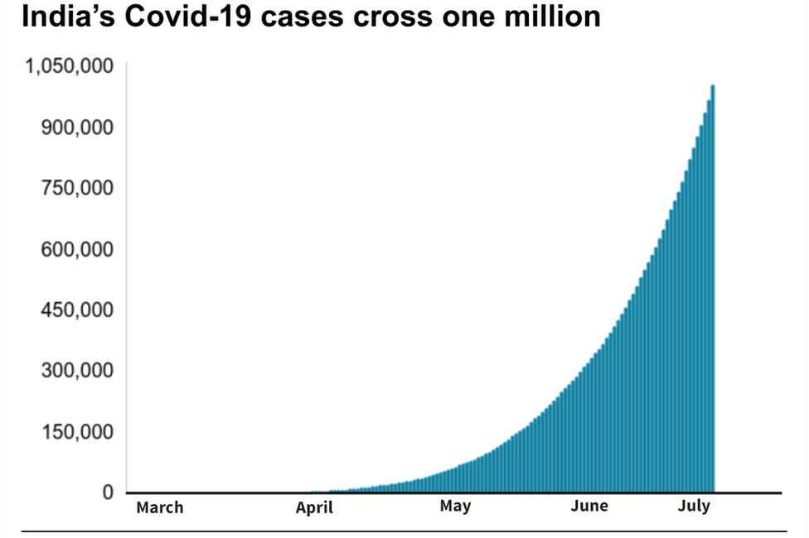

*Figure 1 COVID 19 cases from March – July [2020] [36]*

India is the world's 2nd-largest consumer of tobacco and 3rd-largest producer. There are an estimated 267 million tobacco users in India, with 28.6% of the population (42.4% men and 14.2% women) using tobacco products. The most prevalent type of cancer and the main reason for cancer-related deaths worldwide is India. Lung cancer is the cause of 5.9% of all cancers and 8.1% of all cancer-related deaths in India. Lung cancer incidence rates have significantly increased over time in Delhi, Chennai, and Bengaluru among both sexes.

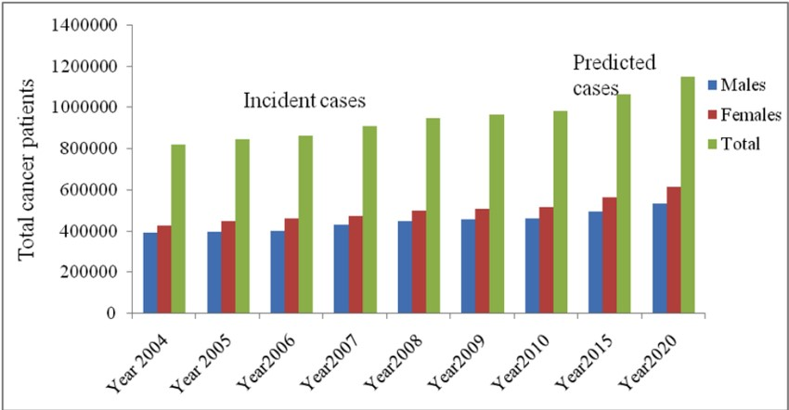

*Figure 2 Year wise total cancer prevalence in India [37]*

The leading infectious cause of death in children worldwide is pneumonia. Numerous infectious organisms, such as bacteria, fungi, and viruses, can cause pneumonia. While most healthy kids can battle the illness with their own defences, children with weakened immune systems are more likely to acquire pneumonia. Malnutrition or undernourishment, particularly in new-borns who are not exclusively breastfed, can impair a child's immune system.

Vaccinations, handwashing with soap, minimising indoor air pollution, HIV prevention, and cotrimoxazole prophylaxis for children who are HIV-infected and exposed are all ways to avoid pneumonia in children. Focusing on ensuring that every sick child has access to the proper care, including the medications and oxygen they require to recover from pneumonia, whether from a community-based health worker or in a medical institution if the condition is severe.

# 1. Literature Review:

In this paper [1], the authors have proposed an innovative deep learning technique where its framework is made up of combination of Visual Geometry group based neural network (VGG), spatial transformer network (STN) and data augmentation along with the Convolutional Neural

Network (CNN). They named this model as VGG Data STN with CNN, in short, VDSNet.

Timely detection and diagnosis of any disease is very crucial for one’s survival, all the more in case of lung diseases. The authors aimed to make the detection process of the lung disease easy with the help of Machine learning methodology. Authors have taken huge datasets of Chest XRays of lungs as input from Kaggle repository. Performance of VDSNet has been tested with CapsNet which is one of the strongest algorithms as it is very sensitive to images than compared to any other CNN algorithms. Basic steps like data preprocessing and metrics (assigning 0.5 F score with recall and precision) have been taken care before implementation of VDSNet. VDSNet is dividing into 3 parts; Spatial Transformation Layers (lamda, batch normalisation, spatial transformer), Extraction of feature layers (VGG16 model) and Classification Layers(Flattened layer and two dense dropout layers). VGG16 model have 5 layers, it has 5 max pool layers, 13 convolutional layers and 3 dense layers. Tests have been performed with various CNN models and it was proven that VDSNet has outperformed all the other models in terms of accuracy.

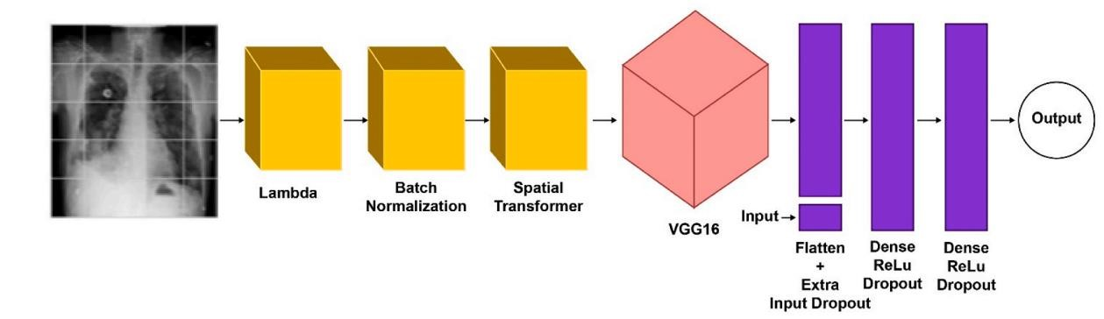

*Figure 3 Full Architecture of VDSNet [1]*

In the paper [2], A new hybrid technique is proposed by the authors where CNN works handin-hand with the Support Vector Machine (SVM). SVM has been employed as it removes the unnecessary information that reduces the accuracy. Data augmentation techniques were employed to balance the given data set and also improve its quality and efficiency. The proposed CNN model had 4 steps: (i) the convolution layer, (ii) the pooling layer, (iii) the flattening layer and, (iv) the fully connected layer. The convolution layers extracts the feature maps from the input images of the dataset and later the feature maps were exposed to ReLU activation function that brings non-linearity into the picture. In the pooling layer, max-pooling has been employed to reduce the size of feature map using a filter/window function. In the flattening layer, the feature maps are flattened into a column. The fully connected layer consists of Support Vector Machine (SVM) where each feature map is mapped to its correct output using neurons. The dataset is divided in to training and testing datasets, along with recall and specificity, significant accuracy of 97.91% was achieved.

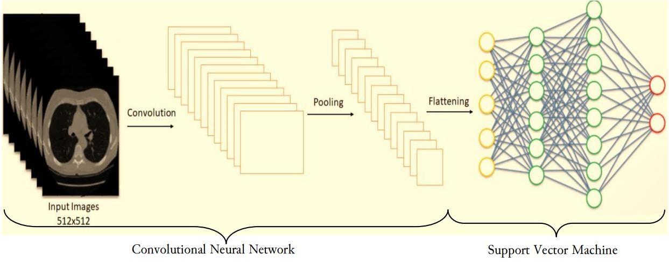

*Figure 4 A flow chart of the architecture of CNN in conjunction with SVM [2].*

In [3], the authors have developed a model using Faster R-CNN algorithm which was proved to show very good accuracy rate for detection of lung nodules thereby providing a crucial detection of lung diseases if any present so that timely treatment is given. The importance of Computer-Aided-Detection (CAD) is rising exponentially in the field of medical science. This model works in a different 2 stage model; initially newly suspicious nodules frames are extracted from the input image and sent it to step 2 using methods such as mathematical morphology, shape curvature etc; step 2 is reduction of the dales positive rate using combination of analysis that includes size, density, texture and gradient features. Drawbacks of traditional methods are low efficiency and the detection theory and practical tests are quite different that leads to deterioration of overall result. Faster R-CNN is a combination of computer vision knowledge and deep learning techniques. It had 4 steps: step 1 is it looks into those areas via selective search and extract candidate boxes, step 2is use CNN and develop feature maps, step 3 has spatial pyramid pooling convolutional network (SPPNet) that works on ROI pooling layer where input and output image is of same size. Key note is that SPPNet needs only one operation as its mapping quality and speed at which it performs is way faster than that of R-CNN, hence the name Faster R-CNN. Step 4 is SVM classifier in fully connected layer to map the received feature maps with the output using neurons. Another important part of this model is RPN (Regional Proposal Network) uses back propagation and stochastic gradient descent. This RPN Network maps the features to final output layer of shared part of R-CNN. Tests are performed and this model showed a very good accuracy and holds potential value in medical field.

In paper [4], work of detection of Tuberculosis using X-ray images by CNN Model that using various techniques like shuffle sampling with cross validation while training the network in order to remove the imbalance and improve efficiency of the model, has been achieved by the authors. Tuberculosis has been a global epidemic since ages, it is curable if and only if it is detected and diagnosed at the bud stages. In this paper [4], two Convolutional neural networks, AlexNet and GoogLeNet are extensively trained and tested with huge datasets of TB X-Ray images to improve the detection accuracy of the network. The architecture of AlexNet and GoogLeNet are as follows: Softmax layers at each category to the score, to reduce overfitting and convergence issues, the authors have used dropout and ReLU and Stochastic Gradient Descent with combinations of different parameters. AlexNet is a 7layer architecture with 5 convolutional layers and 2 fully connected layers whereas GoogLeNet is a 22 layered CNN model. Shuffle sampling was used to balance the dataset as it becomes very difficult to classify if the dataset is not balanced. Experiments with training dataset and texts are performed and it was observed that for AlexNet, with a base learning rate of 0.01 and weight of 0.0005 yielded an optimal result within a reasonable time frame. In case of GoogLeNet, base learning of 0.001 and weight of 0.0002, yielded optimal results.

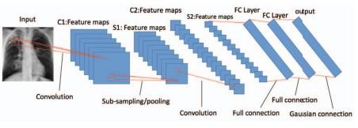

*Figure 5 LeNet CNN architecture used for TB Classification. [4]*

In this paper[5], the authors have proposed a unique Convolutional Neural Network algorithm where the model learns convolution filter patterns of each kind of pneumonia. This is done by restricting certain filter layers in convolution layer so as to specifically focus the model to respond only to a particular class of covid 19 or pneumonia. Learning robust features and strengthening the gradient flow between is the main aim of the proposed work to deliver correct output (accuracy) and also to visualize those regions on X-rays which are salient and has the maximum influence on the result of CNN. Authors have proposed CNN network having 2 architectures: Channel-Shuffled Dual-Branched (CSDB) CNN and CSDB CNN augmented with distinctive filter learning (DFL) paradigm. They used 2 architectures as it provides dual residual connectivity across blocks, channel shuffling and correlation of variably sized receptive fields. The approach utilized the weighted gradients of filters so that the target class is used to identify a specific set of filters to result maximally only to a particular output class. Inclusion of additional loss function reduced the distance between activated filters within the same class and also to maximise the distances between various dissimilar classes. This model apart from uniquely identifying filters and assigning classes, it also converted 1 convolutional layer into a dual-purpose learner by learning to extract features just by tuning the filters, it also works well with the least number of parameters. Datasets have been taken for training and testing, it was observed performance in terms of accuracy and F1-score is much better than compared to other CNN Models.

In this Paper [6], authors used Convolutional Neural networks (CNN) to various chest diseases with enhanced accuracy and detailed precision among CADs (Computer Aided Diagnosis). Chest Diseases like pneumonia, edema, infiltration is very dangerous and needed correct detection and treatment at early stages to cure it. Along with CNN, Back propagation neural networks (BPNN) and competitive neural network (CpNN) are used for the classification of Chest X-Ray diseases. The Input provided was Chest X-Ray datasets which contained thousands of X-Rays of variable sizes, that were obtained to train the neural networks. The neural networks were trained and tested with a large number of iterations. It was seen that input size of image of 32×32 pixels showed comparatively best performance that yielded a very good recognition rate. The results proved that CNN was more efficient at recognising and classifying the disease with an outstanding accuracy of up to 92.4%. the excellence of CNN is attributed to it’s Deep structure that uses extraction of features at different levels which outperformed BPNN, CpNN and became capable better at generalisation.

In this paper [7], Authors have used multiple techniques to identify or detection of the target area of pneumonia from the given input (X- rays). The backbone of the network is DeepConvDilated Net which is a low complexity residual neural network and along with DeepConvDilated Net, a 2-stage detector Faster R-CNN has been used as a structure. DeepConv-Dilated Net is mainly used for identifying and localising pneumonia in Chest X-rays. It provides data with depth and also removes computational lag. The Soft-NMS basically ensures the sample quality and screen boxes and filter the overlapping anchor boxes that were generated by RPN (Regional Portion Network). The authors also used K-Means++ to generate anchor boxes and to analyze the target region. While model training, the Dataset has been enhanced by the CLAHE algorithm in terms of constrast and brightness. DeepConv-Dilated Net not only enhances the feature extraction mode of network but also removes the up-sample layers in FPN (Feature Pyramid Network). After training and testing the model, authors have developed DeepConv-Dilated Net+ Faster R-CNN model which showed significant accuracy in terms of detection of target layer than COD algorithm.

In paper [8], authors named their proposed work as EFFI-CNN, an efficient CNN model that has seven CNN layers namely Convolutional Layer, Max-Pool Layer, Convolution Layer, Max-Pool Layer, fully connected layer, fully connected layer and soft-max layer. The uniqueness of the model is that it uses a unique combination of CNN layers with parameters of depth, height, filter height, width and filter width. The use of convolution layer is abstracting features from the input image and generates feature maps or activation maps using some dimensional filters or kernels. In Max-Pooling layer, the dimensionality of the feature maps is reduced. It is one of the types of spatial pooling. The Fully Connected layer has neurons and each and every neuron in the previous layer is connected to the neuron of its consecutive layer. It is basically to classify the input image based on the extracted features at the convolution layers. Soft-max layer has soft-max function which is an activation function that basically converts numbers into their respective probabilities which is very crucial while classification. The proposed work has shown that results of EFFI-CNN are promising than other CNN models like ICDSSPLD-CNN and EASPLD-CNN.

In paper [9], The authors have proposed a hybrid model of Convolutional Neural Network and Contrast-Limited Adaptive Histogram Equalization (CLAHE) to classify different Lung diseases. At the beginning, the authors implemented the model using a support vector machine with and without CLAHE equalizer and tests were performed and later after inclusion of CLAHE Equalizer along with CNN network, it was observed a rough 20% increase in accuracy than compared to traditional methods. CLAHE algorithm is based on dividing the image into non-overlapping areas of similar sizes and interpolate them to fix any anomalies present between boundaries. It was basically used to enhance the contrast of image and define the edges of image more clearly.

The classification model proposed is based on CNSNs (Convolution Neural Spectral Networks), the input image’s spectral properties are captured by CNSN model ad it extracts different features from the image using particular parameters and CNSN Models. After extraction part, it combines them all into a single feature vector which serves as an input for the dense layer. In the dense layer or fully connected layer which is also called as feedforward neural network where every neuron is connected with every other neuron of next layer, the feature map that is flattened act as an input and gets mapped with the output. These procedures are performed many times with internal shuffling of training datasets in order to improve the accuracy of the model for classifying the X-Ray images.

In this paper [10], The researchers proposed two architectures: Artificial Neural Networks (ANN) and a hybrid model of AlexNet and Bidirectional Long Short-Term Memories (BiLSTM) layer that looks into the temporal properties. The proposed algorithm takes input images, performs pre-processing techniques on the input image like Lung segmentation to remove the noises in the data which would lead to false prediction and thus false classification, data augmentation improves the visual features like color, texture, geometry of the images thereby significantly improving the learning abilities of the model. Next the pre-processed dataset is put into mAlexNet, a combination of AlexNet and BiLSTM, which extracts the features from the input image and generate feature maps which are later served as input for dense layer. The fully connected layer classifies the feature maps with the help of neurons and soft-max function. The proposed model has transfer learning based modified AlexNet that has 25 layers that contains convolutional layers and uses max-pooling to reduce the size of the network, fully connected layers, ReLU, normalisation and soft-max output layer.

Also Flatten and Bidirrectional Long Short-Term Memories (BiLSTM) layers have been added to the AlexNet architecture. BiLSTM and LTSM has Recurrent Neural Network (RNN) architecture to process sequential data. Basically, RNN assumes a relationship between input data which makes it suitable for sequential as well as temporal data and relationship between data is examined in two directions alongside storing the historical information by both BiLSTM and LSTM. While training, Adam Optimisation algorithm is employed to reduce the error in each iteration.

After the training and testing phases, the researchers observed that model 1 (ANN that has only AlexNet architecture) showed an accuracy of 98.14% in detection of Covid-19 whereas the hybrid model (combination of AlexNet and Bidirectional Long Short-Term Memories

(BiLSTM)) showed an improvement in accuracy of 98.70% and thereby outperforming model

1.

In this Paper [11] authors conducted a series of experiments using supervised machine learning model to obtain accurate data sets consisting of medical images of covid-19 patients. The authors present the first experiment using convolution neural networks on a newly created database of covid-19 images. The main aim of authors is to establish a baseline for future development of a system that automatically detects covid-19 diseases based on symptoms on the given chest x-rays and compute tomography images of lungs.

The authors stated that further developments for detecting covid-19 from chest x-ray images using development tools such as AI tools which came after medical images were made for diagnosing the covid-19 virus. Authors state that CT scans have been found to be the best type of image for diagnosing virus in images.

Further in this paper authors explained about the methodology in detail they stated that this experiment used the dataset published by Cohen. It consists of 338 chest x-ray images which is used to train deep learning model because a chest x-ray is often one of the first test a person undergoes when a respiratory disease is suspected. As conclusion the authors stated based on the results of implementation of experiments the best accuracy was obtained from feature based feedforward neural network was 94.30%, this experiment also a had trait based feed forward neural network with accuracy of 84.02% and a third experiment is a combination of two databases and it is also best method which obtained almost 100% accuracy.

In this Study [12] authors stated that medical imaging methods such as chest x-ray and CT images are most commonly used in diagnosing covid-19. These deep learning methods plays an important role in assisting radiologists in screening. The authors proposed a deep learning based system for diagnosing covid-19 using chest x-ray images called COVID-XNet. This deep learning model runs on series of pre-processing algorithms it takes image as input to reduce variability and to enhance contrast. Then it is given into a custom convolutional neural network to extract certain features and to define classification between covid-19 and normal cases. The authors have given a detailed explanation about the materials and methods used for this COVID-XNet model.

Authors obtained chest x-ray images from the BIMCV-COVID19+ dataset which was provided by Medical Imaging Databank of the Valencia Region and they also used dataset collection by Cohen. They also collected chest x-ray images of healthy patients to train the COVID-XNet deep learning model. The first method which is used by authors is Preprocessing step which have different techniques, which will be applied to the input images in order to reduce the variability of these images. The next step is convolution neural network this COVID-XNet model has 5 CNN layers, four Max pooling layers, a gap layer and a softmax layer and also have conv1, conv2, conv3 uses 5×5 kernel size, conva and cov5 use 3×3 kernel size and all max pooling layers use 2×2 kernels.

After these two steps authors does training and testing the COVID-XNet model. Then the fourth step is Performance Metrics is used to measure the performance of the COVID-XNet model. The Fifth step is Class Activation Maps. As a conclusion the authors does PostProcessing for the covid-19 detection in x-ray images only lies inside lung area. From methods the original image get segmented in order to discard surrounding and unwanted portion of original image with this process CAMs can focus on the area which is affected by covid-19 and get clearer results. The authors concluded that this COVID-XNet model has achieved accuracy of 94.43%. The output of this model highlights the finding for covid-19 in x-ray images.

In this Paper [13], Medical image classification is most recognized technique for detection of disease, including various methods such as x-rays, computed tomography (CT). Chest x-ray is an imaging method that plays an important role in detection of covid-19. In this article authors proposed an deep learning model called DenseNet model to classify covid-19 chest x-rays. To propose this model authors used a accessible data set which has 6432 chest radiography which are classified into 3 classes are used. Transfer learning and fine tuning are used to train the variants of DenseNet model which are DenseNet121, DenseNet169, DenseNet201. For the research authors carried out experiment using Google Colab.

Further in the paper authors detailed described about datasets used to train the DenseNet deep learning model. In this experiment there are 6432 image files it is taken from Kaggle dataset repository. The dataset has 2 folders for training and testing the DenseNet model respectively. Among the 6432 x-ray image files of training set it has 460 image files are of covid-19, 1266 image files for normal patients and 3418 image files are of pneumonia class respectively. In testing set of image files 116 image files of covid-19 chest x-ray, 317 image files of normal chest x-ray and 855 image files are of pneumonia class respectively.

The authors stated training a convolution neural network model from scratch time consuming and computationally expensive process. So they used a pre-trained CNN model using huge dataset like ImageNet that contains millions of images. In transfer learning, there are two methods used by authors which are pre-trained CNN is used as a feature extractor and for classification the last fully connected layers. The DenseNet model uses Model Hyper Parameters which means this model contains many different activities. The authors also used Data Augmentation which expands the dataset artificially and modify the available images in the dataset to train the model to give more accurate results.

They also use Evaluation Metrics which helps in evaluating the accuracy after the training is completed. The accuracy calculating formula is the ratio of number of correct predictions (If true means positive and False means negative) to the total number of input samples. As a conclusion this DenseNet model has a highest accuracy of 93%.

In this Paper [14], authors proposed method to diagnose covid-19 using x-ray images. The model is based on XceptionNet deep learning model which uses Depthwise separable Convolution which splits the into two steps [depth wise convolution](https://paperswithcode.com/method/depthwise-convolution) applies a single convolutional filter per each input channel and [pointwise convolution](https://paperswithcode.com/method/pointwise-convolution) is used to create a linear combination of the output of the depth wise convolution. This method has 41 layers whose architecture is based on XceptionNet architecture. The dataset used has 1419 images comprising 132 images of covid-19 cases, 619 images of pneumonia cases and 668 healthy cases. Further in the paper authors gave detailed description of this model which takes 224 × 224 pixel image as input. Step 1 is image loading, Step 2 is sample image analysis, Step 3 is image normalization, Step 4 is split train test, Step 5 is Data Augmentation.

The augmented training images are given into convolutional neural network as input. This CNN has basic architecture which contains Convolutional layer, Max pooling layer, Fully connected layer. After the CNN operations K-fold cross validation is performed the training set is divided into k folds to improve accuracy of the training set. Then Model Evaluation is done to compute the score, accuracy, specificity. In the final and the last step Model interpretation based on class activation heatmap is done. The accuracy achieved by this method is 96.16% with a precision of 96.16%. As the authors concluded by stating that this proposed method can be used for detection of covid-19 form the chest x-ray.

In this Paper [15], authors stated Pneumonia is most common and severe disease and early diagnosis and treatment of pneumonia is critical to preventing complications including death. Chest X-rays are most common imaging examination tool used in practice and which is critical for screening, diagnosis and management of variety of diseases including chest diseases like pneumonia.

Authors proposed an algorithm called CheXNet that can detect pneumonia from chest x-ray images. CheXNet is a Convolutional Neural Network model which has 121 layers. The CheXNet model is trained using ChestX-ray14 dataset which is the largest dataset which contains over 1 lakh frontal view x-ray images with 14 different diseases. This CheXNet model takes chest x-ray image as input and gives the output of heatmap localizing the areas of the image infected with pneumonia. The authors used class activation map to create a heatmap that visualizes the image region that has disease. To generate the class activation map, they feed the fully trained network with images and get the output of the feature maps from the final convolutional layers or also know as fully connected layer.

The authors further stated that Chexnet model localizes pathologies it identifies using CAM, which highlights as a heatmap of the areas that are most important for the classification of a particular disease. As a conclusion authors compared the proposed Chexnet model with the radiologist output the accuracy of the proposed model is 0.435 which is higher than the radiologist accuracy which is 0.387.

In this Paper [16], Authors proposed Transfer learning mechanism for detection of pneumonia from chest x-ray images. This mechanism which authors used is simply a basic CNN deep learning model which is trained using small datasets. A Convolutional neural network basically has layers which are Convolution layer, Sub Sampling layer or Max Pooling and Fully Connected Layer which have there own functionalities. The authors stated that CNN model normally out perform when the datasets are usually large. But when dataset are large then The CNN models under perform and have less accuracy. So the concept of transfer learning comes handy, The basic methodology of Transfer learning is shown below

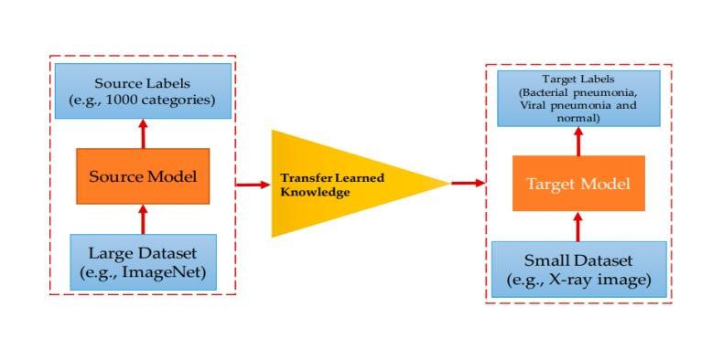

*Figure 6 Transfer Learning Mechanism*

Transfer learning is very useful in many applications which relates to image classification. This removes the barrier of having large datasets and reduces the very lengthy training periods.

In this Paper [17], Authors proposed a Deep Learning Model which helps in detecting pneumonia from chest x-ray images. This CNN deep learning model is called AlexNet which is based on transfer learning mechanism. This AlexNet Model is trained using a small dataset which have a total of 5247 chest x-ray images which consists of normal, bacterial, viral chest x-ray images. The AlexNet Architecture is shown below.

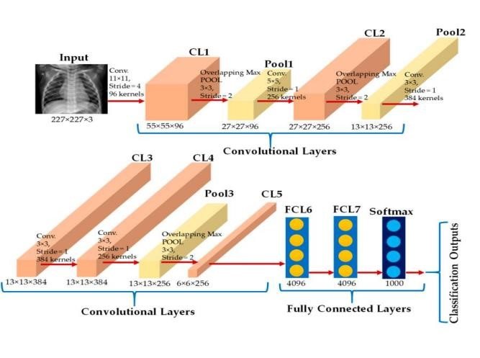

*Figure 7 AlexNet Architecture*

Authors further gave detailed explanation about AlexNet Architecture. AlexNet solves problem of image classification with subset of ImageNet dataset with roughly 1.2 million training images, 50,000 validation images, and 150,000 testing images. The input is an image of one of 1000 different classes and output is a vector of 1000 numbers. The input to AlexNet is an RGB image of size 256*256. This mean that all the images in training set and test images are of size 256*256. If the input image is not 256*256, image is rescaled such that shorter size is of length 256, and cropped out the central 256*256 patch from the resulting image. AlexNet contains 5 convolutional layers and 3 fully connected layers (8 layers total). In the first two convolution layers, each convolution layer is followed by a duplicate max pooling layer. His 3rd, 4th and 5th layers of convolution are directly connected to each other. The fifth convolutional layer is followed by an overlapping max pooling layer, which connects to a fully connected layer. The fully connected layers have 4096 neurons each, and the second fully connected layer feeds a 1000-class softmax classifier.

In this Paper [18], Authors proposed a Deep Learning Model which helps in detecting pneumonia from chest x-ray images. This CNN deep learning model is called ResNet which is based on transfer learning mechanism. This ResNet Model is trained using a small dataset which have a total of 5247 chest x-ray images which consists of normal, bacterial, viral chest x-ray images. The ResNet Architecture is shown below.

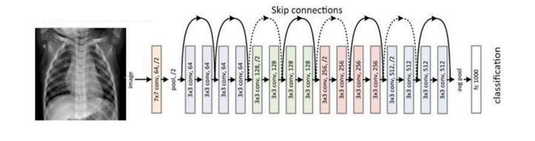

*Figure 8 Residual Network Architecture*

ResNet has different variants ResNet18, ResNet50 and ResNet101 based on the number of layers in ResNet Model. ResNet Means Residual Network the deep learning model was developed to solve two important problems such as vanishing gradient and degradation problem. This work used the Kaggle chest radiograph pneumonia database, which consists of 5247 chest radiographs with resolutions from 400p to 2000p [53]. Of the 5247 chest radiographs containing images, 3906 images were from different subjects with pneumonia (2561 images were images for bacterial pneumonia, 1345 images were 1341 images are from normal subjects. Mixed viral and bacterial infections occur in some cases of pneumonia. However, the dataset used in his of this study did not include cases of viral and bacterial coinfection. This dataset was split into a training set and a test set. The ResNet 50 model achieved a top-1 error rate of 20.47 percent and and achieved a top-5 error rate of 5.25 percent.

In this paper [19], authors have introduced Transfer learning models such as EffcientNetB0, InceptionV3 and VGG16. Generally, the performance of an CNN model is accurately depending on the available of the quality and quantity of the data (medical images) for the training to detect COVID 19 disease. EffcientNetB0 is mainly proposed in this study because of its accurate & efficient results in between the layers. The input as the X-ray image after that by doing image Pre-processing, after training the data set with the 3 Deep CNN transfer models then the final output will be that if the patient has been affected by from the COVID-19 or Viral Pneumonia, if not the patient is a healthy person. The image pixel size of 224×224 has been considered as the standard level of image inputs for training the medical image data.

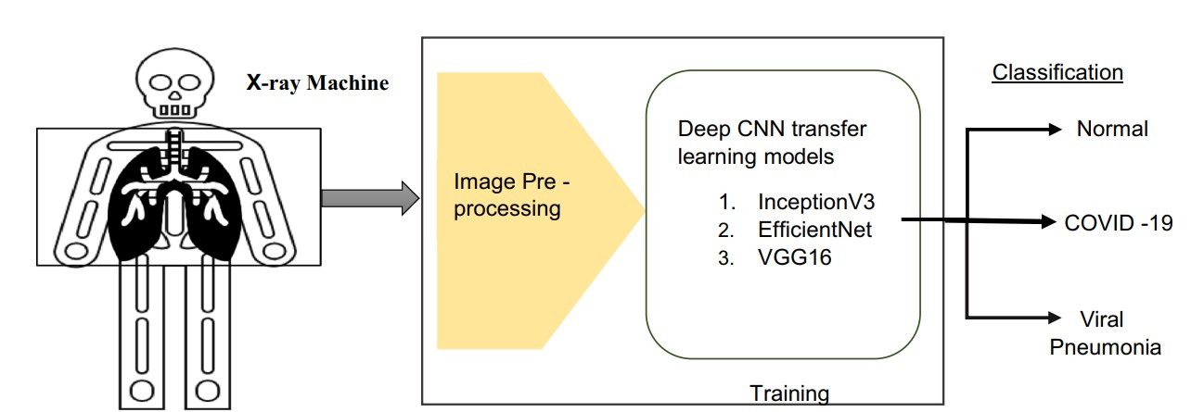

*Figure 9 Proposed Architecture*

Deep learning models has played a significant role in detecting the diseases like COVID 19, Pneumonia etc. The more the amount of medical data the better will be the accurate results for detecting the diseases.

The work done by the authors in this paper [20], the present existing detection methods has failed to detect the different type of trends in COVID 19. Histogram-oriented gradients method has been given the best accuracy results in detecting the COVID 19 in different types of trends.

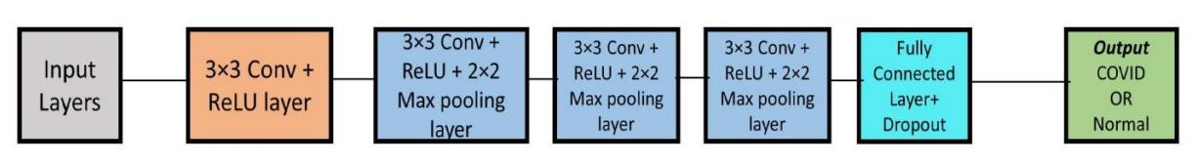

*Figure 10 Proposed Algorithm Flow*

In the proposed model algorithm has the FIVE Convolutional neural layers for the medical data (images) as the input, the from the Chest X-ray has been taken as input then conducting the pre-processing on the image data set followed by extracting the feature on the data set Feature extraction from each image features with 𝑁 (𝑖, 1,550), then finally determining followed by opening layers, max pooling (stride of 2*2), the output data will be evaluated by ReLU feature. The feature extracting with the CNN+HOG taking the input image extracting the features step by step then followed by the classification unit then the final output will be the COVID-19 or Normal. The layers are connected in the network such a way that the provided values will be determine the disease.

In this paper [21], authors have worked on modified MobileNetV2 with RMSprop optimizer.

Authors also explained about the other models such as VGG16, VGG19, InceptionV3, ResNet50, ResNet101, GoogLeNet, MobileNetV2, AlexNet, EfficientNetB7, DenseNet121, NFNet and as well as Modified-MobileNetV2 (Proposed Method). After testing the models, the pre trained Modified MobileNetV2 has the high accuracy results among all the models. The data set consists of chest X-ray image in the data preparation called as training the image without any errors for the further classification follows as for the annotation remover as EnsNet, and then augmentation for checking the data without overfitting or scarcity of the data, then image enhancement & image resizing and then splitting the data set for the different CNN models. As for the performance evaluation considering parameters such as Accuracy, compilation time, sensitivity recall, precision, specificity, F1-score, NPV then the final outcome of the Modified MobileNetV2 classify the disease COVID-19 or Healthy patient. Authors stated that modified MobileNetV2 model has shown major achievement when compared to other CNN models, they are successfully.

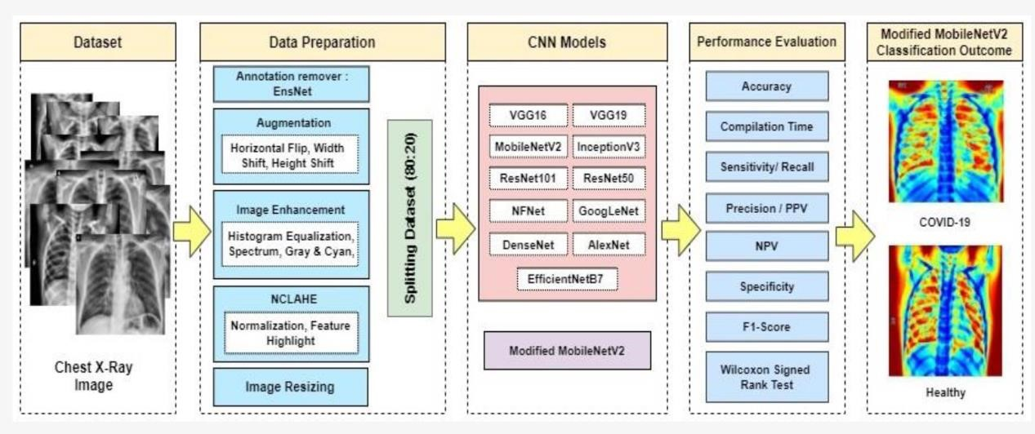

*Figure 11 Proposed System*

All these models working with their best to give the better results but purely depending on these models has been a major drawback for the doctors for them to believe the life of a persons in those trained CNN models, to overcome this fear in the future many more trained models will be introduced.

In this paper [22], authors stated that Deep learning models has majorly increase in medical field especially on diagnosis of the x-rays, some of them like Artificial Neural Network (ANN) and Convolutional Network Networks (CNN), CNN has a huge number of variety models in detecting the diseases. The authors have proposed own CNN architecture which consists of 38 layers (cd layers, max-pooling layer, dropout layer, activation function layer, batch normalization layers and finally with fully connected layers). The image size of 150-by-150 RGB image has been considered in the proposed architecture. To overcome the data size insufficient Data augmentation has been introduced. In the proposed architecture data training was performed rapidly with different data sets to increase the accuracy and performance of the model.

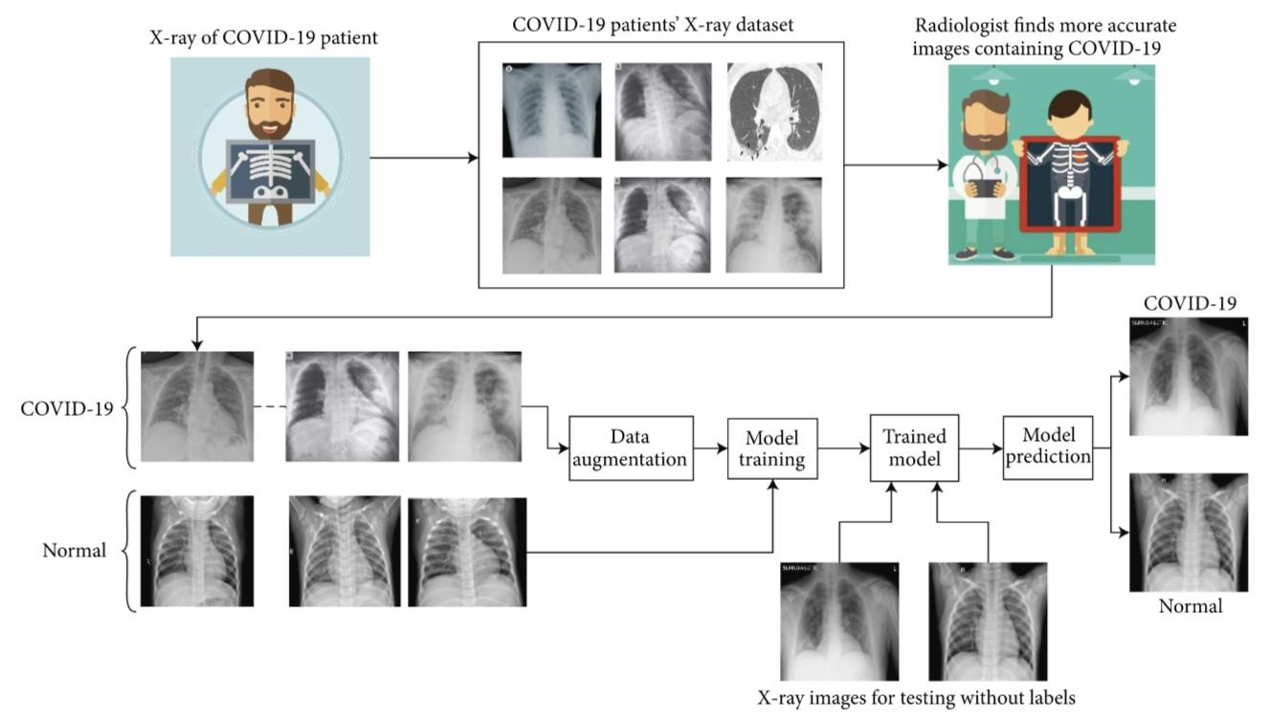

*Figure 12 System Development Workflow*

In this paper [23], authors worked on Convolutional Neural Network models such as: AlexNet, ResNet18, Googlenet, and ResNet50 models. For the image classification in medical field Deep learning is the best choice. The proposed models have fully connected layers, softmax layer as well as an output layer for them to classify the medical images (X-rays). Data augmentation also proposed in the training data for the models to avoid fitting issues. The proposed models have work with their metrics such as accuracy, precision and F-1 score. By using these models and by applying techniques like Data augmentation has given a high accuracy result and helped in detecting the lung cancer in early stage to protect the patients.

Paper [24] Lung cancer is the one of the major deaths causing disease through-out the history, the majority of the death causing from lung cancer because of lack of proper understanding of the disease in the early stages. Artificial Intelligence is a major field and one of its subsets is

Machine learning, which takes a complex decision-making condition in the real life. Over a period, machine learning has its own subsets mainly as supervised learning, Un-supervised learning, Reinforcement learning. The proposed model which will take medical image data and start processing into separate selection of sub tasks, like which task should be presented at that time of work for them to classify, these classifications were done by three classifications models as Support Vector Machine (KVM), K-Nearest Classifier (KNN), Convolutional Neural Network (CNN) and after the training and testing by counting the measures and finally display the accuracy the final outcome.

In this paper [25] authors proposed ResNet-50 Convolutional Neural Network, which is a multilayer convolution neural network having residual blocks, ResNet-50 to detect the disease & to assist the radiologists for their clinical decisions. In this paper Data augmentation approach has been used for expanding the size of the dataset, Pre-trained ResNet-50 has been used for image classification for Pneumonia, then for scaling up of ResNet-50 architecture is by using compound scaling. ResNet-50 has given support to computer-aided diagnosis of Pneumonia. The ResNet-50 has attained accuracy of 98.14%. Depending upon the future works the developing of better ML algorithm which can localize the parts of the lung affected by pneumonia.

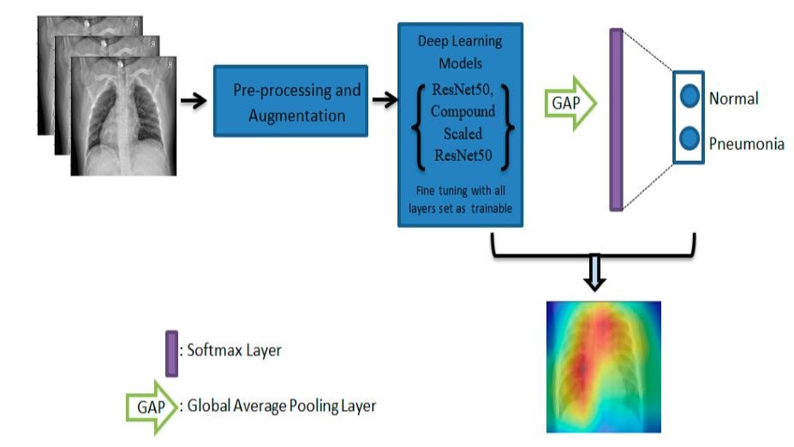

*Figure 13 Block Diagram Representation of Proposed Methodology*

This paper [26] explains how the modern technologies has been improved to detect the pneumonia by using the real time image datasets such as Chest X-rays, also covers different ML based algorithms such as convolution neural network (CNN), k-nearest neighbour (KNN), RESNET, CheXNet, DECNET and Artificial neural network (ANN) which are now majorly used technologies in detecting the Pneumonia disease. According to the report released during World Pneumonia Day, it is estimated that more than 11 million infant children below the age of 5 years are likely to die from pneumonia by the year 2030. Now-a-days ML are quite effective in the medical image detection from the image datasets. Soon there will be chance of increasing the new algorithms to predict the Pneumonia and increasing the accuracy rate, in the hospitals, medical institutions, clinics etc. ML based algorithms will be a great help for to ultimately achieving the worthwhile system for medical image detection in the medical field. However, accepting the ML based algorithms will be a crucial task for every medical background.

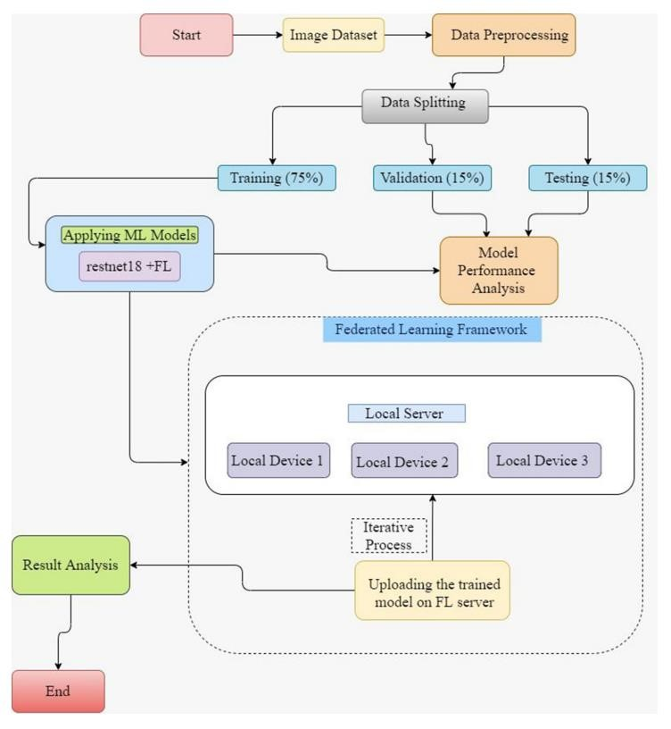

*Figure 14 Proposed Model*

A serious infectious disease called pneumonia affects one or both lungs in human beings. It is caused by a bacteria called Streptococcus pneumoniae. One in three deaths in India is caused due to pneumonia as reported by World Health Organization (WHO).In disease classification, CNNs(Convolutional Neural Networks) and medical images using deep learning algorithms have contributed for the success. Depending on the purpose we choose the optimal CNN model. CNN models along with supervised classifier algorithms are advantageous in detection of pneumonia.

The proposed pneumonia detection model is divided into pre-processing stage, feature extraction stage and classification stage.

In **[27]**, authors mainly focuses to explain the medical adeptness in areas where the radiotherapists are limited. The goal of the study is to facilitate early diagnosis of pneumonia.

World health organization (WHO) research said that one out of three deaths in India is caused by pneumonia. Pneumonia is a fatal disease which effects one or both the lungs which is caused by a bacteria called streptococcus pneumonia. Radiotherapists are required for evaluation of pneumonia for which we use chest X-ray. CNN models along with supervised classifier algorithms are advantageous in detection of pneumonia. CNN models are designed depending on the purpose.

Data argumentation is used for increasing the size of dataset and generalizing the model. Feature extraction is used for detection of desired features using a series of convolutions and pooling operations. In classification completely connected layers act as a classifier on top of the features extracted in the features extraction method.

In the study **[28]** conducted in the year 2022 indicates the best model among the three models to detect pneumonia. They used transfer learning approach to build their CNN model which gave better results and good accuracy than the previous transfer learning methods that were previously available. To further, this will utilize their work to detect and classify X-ray images containing of Covid-19 and pneumonia. In the recent times, there has been an increase in the availability of data which made artificial intelligence-based mechanisms useful by making faster, better and more valid decisions.

In medical field lot of medical images are used for processed using machine learning techniques to provide better accuracy. In this paper it mentions the use of machine learning algorithms to process chest X-ray images and help in determining the correct diagnosis. The goal is to construct a processing model which will help with the classification problem that is detecting whether a chest X-ray shows changes consistent with pneumonia or not.

The first step is collection of images and making a dataset out of the collected images of chest X-rays. In this the data is segregated into 3 folders named train, val, test, in which the images are split into 80/10/10, that means 80% images are used for training the data model. In every folder there are 2 sub-folders containing images reported as pneumonia or normal.

The second step is pre-processing of images. Pre processing is the first step in building a model. The imported images are RGB, for the model ,they are imported as greyscale and resized to 200x200 pixels.

The third step is CNN and tools selection. Tools used were numpy, pandas, keras, jupyter notebook, matplotlib and seaborn. Training and testing was done on a local pc Image classification was done with use of a CNN based machine learning algorithm.

The work in **[29]** mentions about classification of digital images of chest X-rays using deep learning methods and implementation based on CNN model. This model’s accuracy is high nearly approaching 90%. As the accuracy is 90% it can be a prediction model.

In the field of medical image processing, convolutional neural networks(CNN) is playing a very positive role in making the process easier and reliable. In this paper **[30]** a self-constructed CNN trained on a relatively smaller dataset for classification of lung X-ray images is presented. This convolutional neural networks enables classification into one of three categories: healthy, bacterial pneumonia and viral pneumonia. The downloaded images are sorted into two different categories as healthy and infected. The data set is divided into 3 parts that is train, validation , test. And the classifying test data set is divided into healthy , bacterial, viral. As seen below.

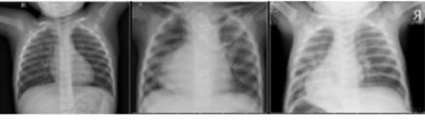

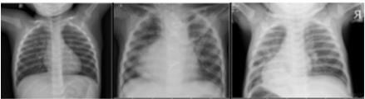

*Figure 15 Train image [14] a) healthy person b) bacterial pneumonia c) viral pneumonia*

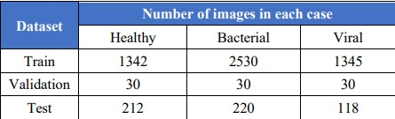

*Figure 16 . Dataset Distribution [4]*

A different CNN architecture was used for data classification with the use of dropout regularization. This CNN architecture model used in paper **[30]** was able to provide quite an accurate classification of 85% of X-ray pneumonia images solving three- class problems (that is viral, bacterial, and control cases. It is crucial that we detect maximum number of positive cases. By making few adjustments the proposed method can be implemented in healthcare systems to support the diagnosis of X-ray pneumonia images in pediatric patients.

Pneumonia is a deadly infection that can cause some serious trouble to lungs if not detected on time. The common method used to detect pneumonia is by using chest X-ray which requires careful examination by experts. The usual method of detecting pneumonia is time consuming and less accurate. In this paper **[31]** a different approach using convolution neural network (CNN) architectures is used to extract features from images of chest X-ray to classify and determine if the person is diagnosed with pneumonia or not. In this to evaluate the size of dataset on the performance of CNN, we train the CNN using both the original as well as the augmented dataset and results the recorded.

There are 2 architectures of this CNN one with a drop out layer and the other without a dropout layer. Both the CNNs consist of convolution layers which is divided into 2 parts which are differentiated by taking different sizes of convolution layer and max-pooling layer.

The dataset used in this work is selected from Kaggle and consists of 5863 images of chest Xray. The dataset is divided into 3 parts naming training, validation and testing. As different images are of different size they all are resized to 64x64. To ensure better performance from the CNN architecture the images are flipped, rescaled etc. We can further improve the proposed CNN architecture by using data augmentation.

Pneumonia is a bacterial infection occurs in our lungs. Early diagnosis is an very important factor in terms of successful treatment process. Usually chest X-ray images are used are used for diagnosis. In this paper [32] we use two commonly known convolutional neural network models Xception and Vgg16 for diagnosing pneumonia. In the training stage methods like transfer learning and fine-tuning is used. Test results showed that Vgg16 network exceed Xception network with an accuracy of 0.87%, 0.82% respectively. However Xception resulted in showing more successful results In detecting pneumonia.

In this paper **[32]**, we use a dataset consisting of 5856 chest X-ray images provided by kermany et al. the data sets are divided into 3 sets as training, validating and testing phase. The training time data augmentation method was utilized. The methods we used for augmentation are shifting, zooming, flipping, rotating at 40-degree angles.

From paper **[32],** we get to know that every network has its own detection capabilities on the datasets. Xception network was more better than Vgg16 in detecting pneumonia, while Vgg16 is more better in detecting normal cases and to achieve more successful results of diagnosing pneumonia, we can combine the strengths of both the networks.

A challenging task in current day is the increasing size of the medical images repositories which is leading to troubles in huge database management and also for querying those databases. Content bases medical image retrieval (CBMIR) systems. In **[33]**, authors have showed a new and better framework by using of deep CNN for the feature based medical image retrieval (FBMIR) system for fast and better retrieval of medical and clinical images for detecting pneumonia. In the architecture proposed by the author consists of input layer, convolution layers, pooling layers, fully connected layers and a output layer.

This framework has three components. The first is the classification task which is used to generate mid-level features.

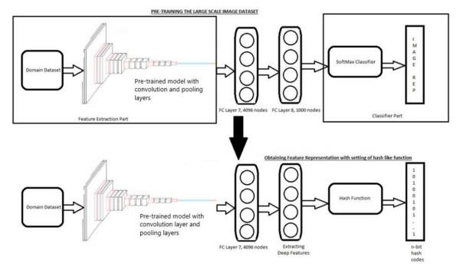

*Figure 17 The proposed framework (QBMICR) [7]*

the second component consists of hash layer for generating n-bit hash codes for fast and efficient image retrieval task. As shown in Figure 3 [34] and the third component does the work of taking input as an image and generates the hash code by using both the components and returns the most similar images.

By using the approach mentioned in **[33]** the results show an accuracy up to 93.9% with sensitivity 97.5%, specificity 87.1%, PPV 93.3% and NPV 95.0%.

In this **[34]** the author aims to develop a model which will help with the classification of chest x ray images and will report us if it’s a healthy(normal) or abnormal(sick). CNN (convolutional neural network) models are usually used to increase efficiency and accuracy. In this study, we got to know that through multiple steps of pre-processing it showed that deep learning technique for the classification showed best results.

The proposed system consists of steps that can be divided into 4 phases: Data set, data preprocessing, building and validating classification models and feature extractions.

In the first step we collect chest X-ray dataset which consists of both normal and pneumonia images. 80% of data is used for training, 10% for testing and 10% for validation. In the second step various pre-processing techniques are used on the dataset

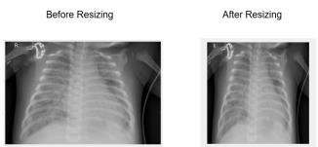

*Figure 18 Image Resizing*

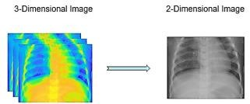

*Figure 19 Image Dimension Reduction*

In the third step various machine learning models are used for classification of pneumonia XRay images from normal ones. Many Machine learning algorithms are used for classification of dataset.

By using the model, mentioned in **[34]** the accuracy score is 98.46%. with some modifications of parameters this CNN model could achieve even better results and also can be applied for diagnosis of diseases such as COVID -19.

For a Non-Professional, it is difficult to say if he has pneumonia through chest X-ray images. But using CNN the diagnosis is efficient. This study focuses on using multiple variants of CNN for detection of pneumonia.

Firstly, we take the dataset for the experiment, in this paper **[35],** 5863 chest X-ray images of both normal and pneumonia are used. And then we use the method of data pre-processing on the dataset where we convert into pixel grid and then convert then into floating point tensor.

Later data augmentation is used to change the view of the data.

In the fine-tuning model stage the learning rate is set and total number of epochs is set to 100.

Experimental result are mentioned below in the form of table.

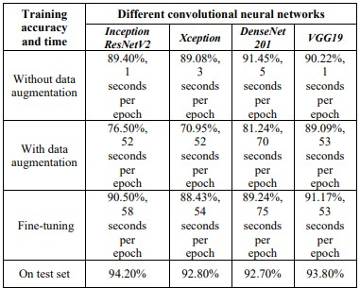

*Figure 20 Experimental Results*

The following conclusions can be made from **[35],** while using variants of CNN to find out the secondary patterns of classification tasks, the advantages of feature tasks, data augmentation and fine tuning are obvious. Every method has their advantages like fine tuning achieves high accuracy than data augmentation but its training speed is fast. CNN variants like InceptionResNetV2, Xception, DenseNet201 and VGG19 out of which InceptionResNet achieved highest accuracy of 94.20%.

# 3. Methodology

### Neural Network

* Neural networks reflect the behaviour of the human brain, allowing computer programs to recognize patterns and solve common problems in the fields of AI, machine learning, and deep learning.
* A computational model that works in a similar way to the neurons in the human brain.
* Each neuron takes input, performs some operations then passes the output to the following neuron.
* A powerful technique to solve many real-world problems.

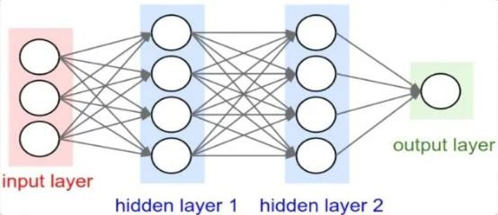

### Convolutional Neural Network

Convolutional Neural Network are distinguished from other neural networks by their superior performance with image, speech, or audio signal, inputs.

* It is a subset of deep learning.
* Convolutional neural network (Convnet or CNN) is one main categories to do images recognition, images classification, object detections, face recognition etc.
* CNN is heavily based on computer vision.

There are 3 basic components to define CNN:

1. The Convolution Layer
2. The Pooling Layer
3. The Fully Connected Layer

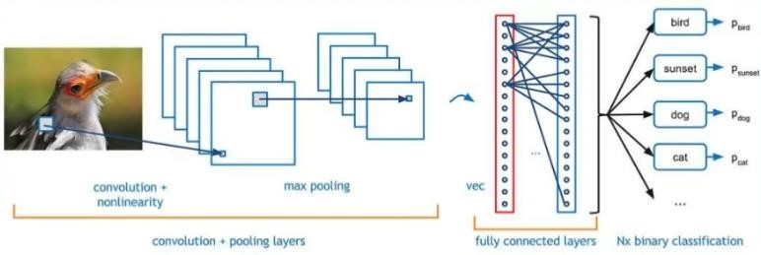 *Figure 21 Architecture of CNN*

### Convolutional Layer

* Computers read images as pixels and it is expressed as matrix (NxNx3)-(height by width by depth)
* The Convolutional Layer makes use of set of filters. A filter is used to detect the presence of specific features or patterns in the original image(input).
* The output is expressed in form of matrix (MxMx3), with a smaller dimension but same depth as the input image.

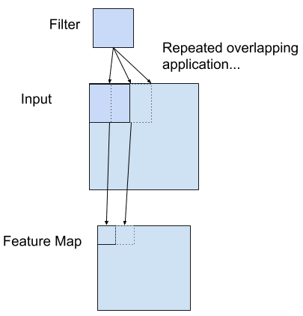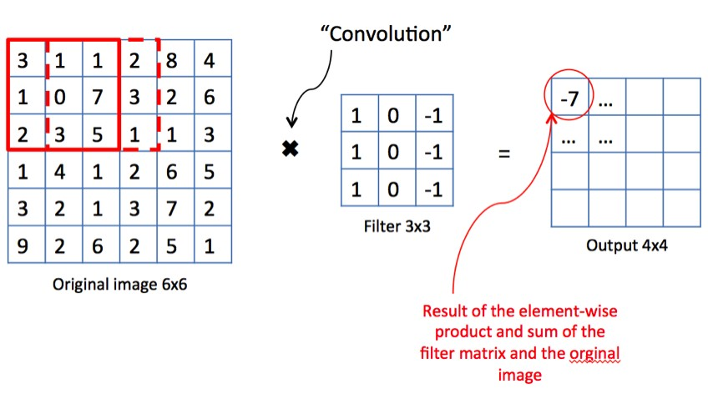

### Padding

* Every time after convolution operation, original image size getting shrinks, as we have seen in above example six by six down to four by four and in image classification task there are multiple convolution layers so after multiple convolution operation, our original image will really get small, but we don’t want the image to shrink every time.
* So, in order to solve these two issues, a new concept is introduced called **padding.** Padding preserves the size of the original image.

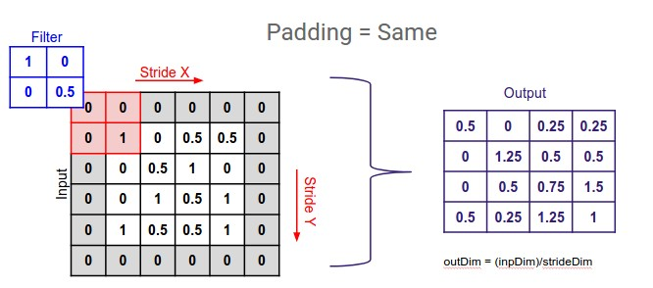

### The Pooling Layer

* The Pooling Layer is seen in between the convolution layers in CNN architecture.
* Pooling is done for sole purpose of reducing the spatial size of the image.
* Max pooling is a pooling operation that selects the maximum element from the region of the feature map covered by the filter. Thus, the output after max-pooling layer would be a feature map containing the most prominent features of the previous feature map.

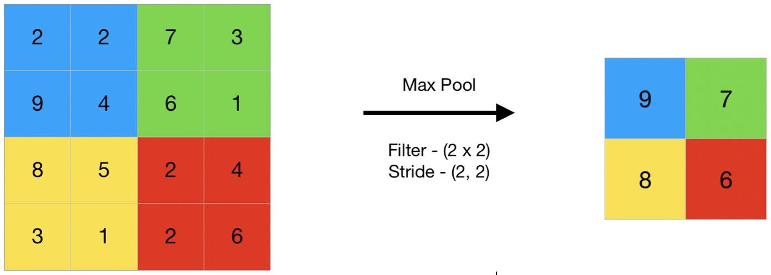

The Output Layer (or) Fully Connected Layer

* The term "Fully Connected" implies that every neuron in the previous layer is connected to every neuron on the next layer.
* The output from the convolutional and pooling layers represents high level features of the input image.
* The purpose of the fully connected layer is to use these features for classifying the input image into various classes based on the training dataset.

# 4. Simulation

### For COVID 19

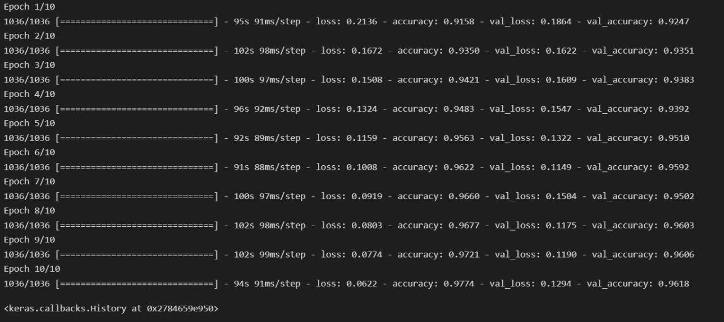

As we can see here for each iteration the accuracy is increasing and the validation loss is decreasing and the validation accuracy also increasing

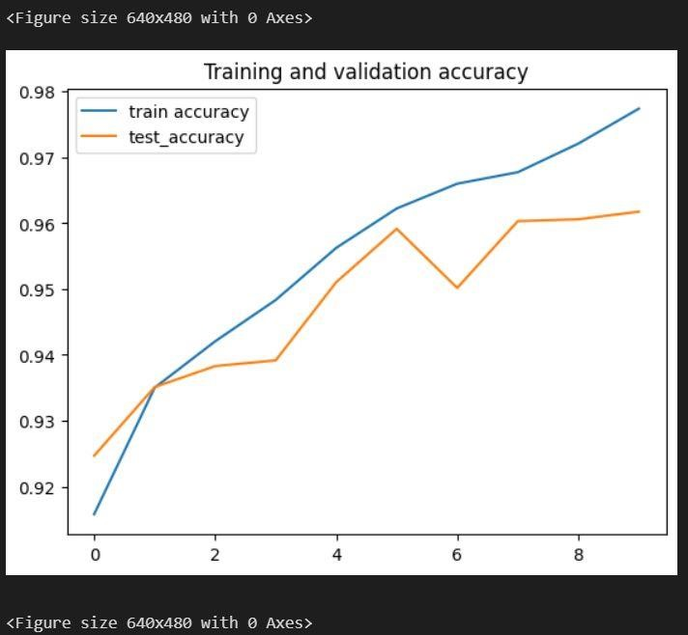

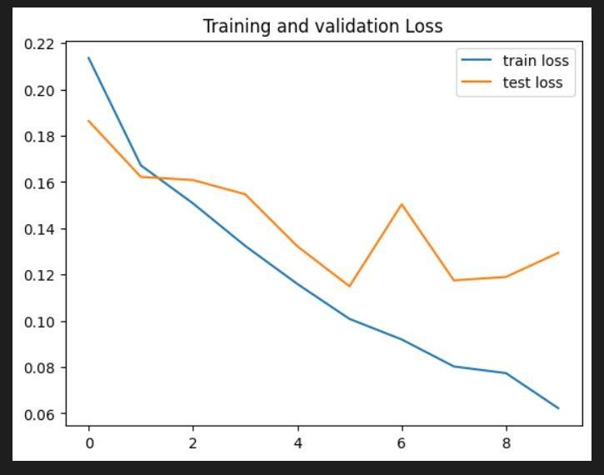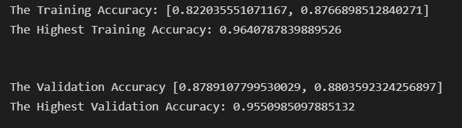

### For Pneumonia

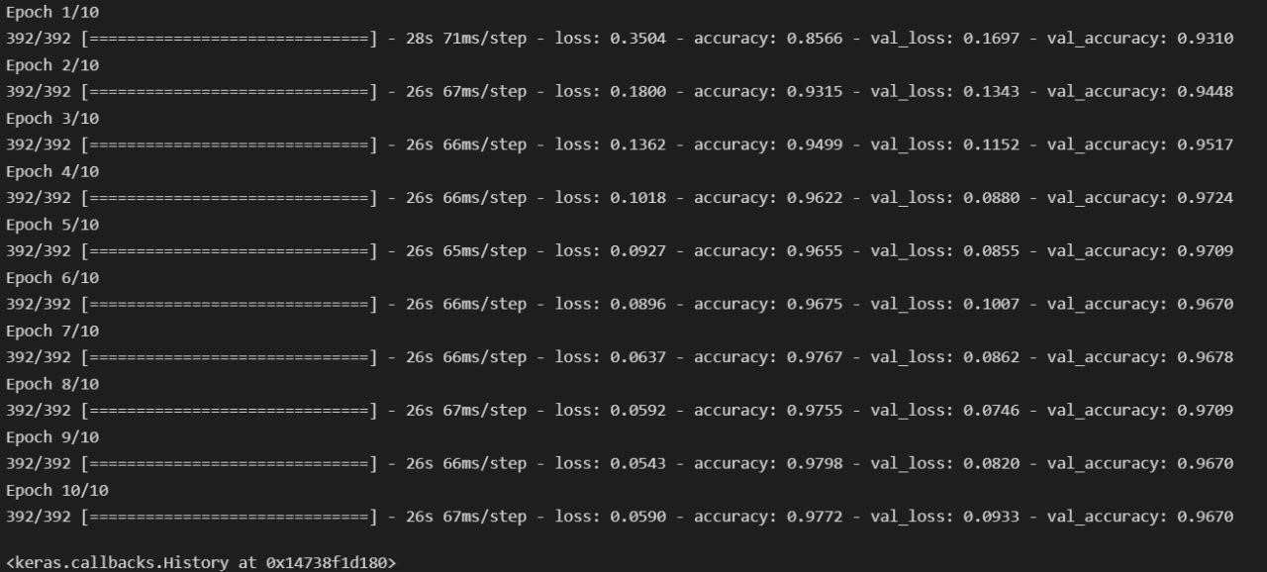

As we can see here for each iteration the accuracy is increasing and the validation loss is decreasing and the validation accuracy also increasing

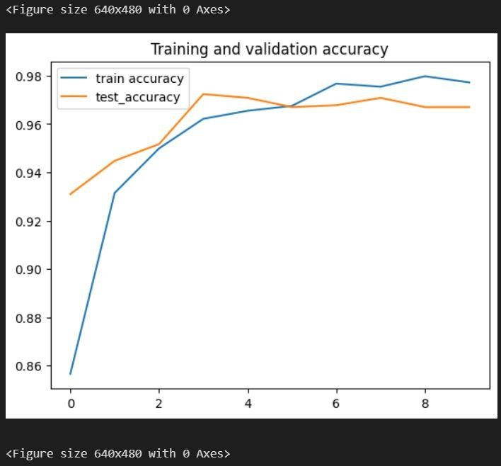

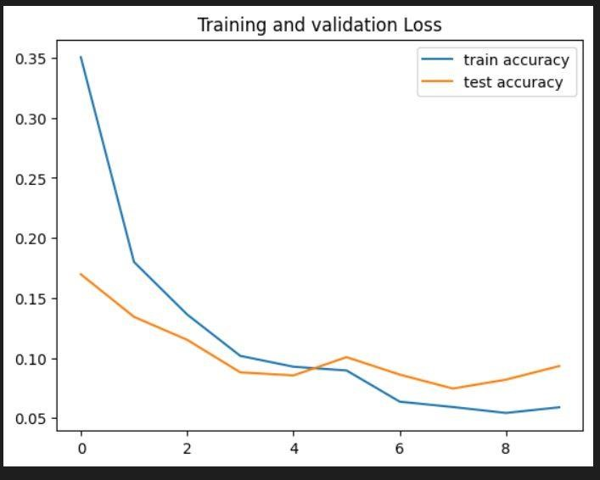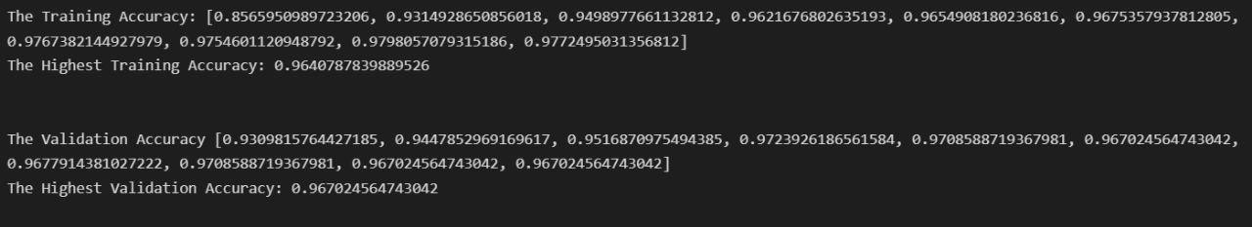

## 5. Concluding Remarks

This paper describes the use of deep learning algorithms using the CNN architecture to classify the dataset consisting of chest X-ray images detect the presence of pneumonia or COVID-19. Many pre-processing techniques are used for increasing the accuracy. As a result, by this approach gave us satisfying results. Accuracy of 95% for COVID-19 and 90% for pneumonia was achieved.

# 6. Future Work

In the current work 2 different CNN models are built for detection of Pneumonia and COVID-19, we plan to convert these two models into one so that it can detect both the diseases using single CNN model.

We also plan to make this model into an App which can be used in mobile phones. Which makes the life of disease detection easy and better. As before, for detection of any disease a doctor is required. But now by sitting in our home we can know detect these dangerous diseases.

# References

1. Hybrid deep learning for detecting lung diseases from X-ray Images. Subrato Bharati, Prajoy Podder, M. Rubaiyat Hossain Mondal.
2. Lung cancer medical images classification using Hybrid CNN-SVM. Abdulrazak Yahya Saleh, Chee Ka Chin, Vanessa Penshie, Hamada Rasheed Hassan Al-Absi.
3. Lung Nodule Detection based on Faster R-CNN Framework. Ying Su, Dan Li, Xiaodong Chen.
4. TX-CNN: Detecting Tuberculosis in chest X-Ray images using Convolutional Neural Network. Chang Liu, Yu Cao, Marlon Alcantara, Benyuan Liu, Maria Brunette, Jesus Peinado, Walter Curioso.
5. Learning distinctive filters for COVID-19 detection from chest X-ray using shuffled residual CNN. R. Karthik, R. Menaka, Hariharan M.
6. Deep Convolutional Networks for Chest Diseases Detection. Rahib H. Abiyev and Mohammad Khaleel Sallam Ma’aitah.
7. Pneumonia Detection using an improved algorithm based on Faster R-CNN. Shangjie Yao, Yaowu Chen, Xiang Tian and Rongxin Jiang.
8. Efficient CNN for Lung Cancer Detection. Venkata Tulasiramu Ponnada, S.V. Naga Srinivasu.
9. Hybrid CLAHE-CNN Deep Neural Networks for Classifying Lung Diseases from X-Ray

Acquisitions. Fairouz Hussein, Ala Mughaid, Shadi AlZu’bi, Subhieh M. El-Salhi, Belal Abuhaija, Laith Abualigah and Amir H. Gandomi.

1. CNN-based transfer learning–BiLSTM network: A novel approach for COVID-19 infection detection. Muhammet Fatih Aslan, Muhammed Fahri Unlersen, Kadir Sabanci, Akif Durdu.
2. A. Altan, S. Karasu, Recognition of COVID-19 disease from X-ray images by hybrid model consisting of 2D curvelet transform, chaotic salp swarm algorithm and deep learning technique, Chaos Solitons Fract. Nonlinear Sci. Nonequilib. Complex Phenom. 140 (2020) Article no. 110071, pp. 1–10.
3. Zheng, Y.Y.; Ma, Y.T.; Zhang, J.Y.; Xie, X. COVID-19 and the cardiovascular system. Nat. Rev. Cardiol. 2020, 17, 259–260.
4. Ali, T et al. (2020) “Correlation of chest CT and RT-PCR testing for Coronavirus disease

2019 (COVID-19) in China: A report of 1014 cases,” Radiology, vol. 296, no. 2, pp. E32–E40.

1. HUANG C, WANG Y, LI X, REN L, ZHAO J, HU Y, ZHANG L, FAN G, XU J, GU X, CHENG Z. Clinical features of patients infected with 2019 novel coronavirus in Wuhan, China. The Lancet, 15 (395), pp. 497-506, 2020.
2. Aydogdu, M, Ozyilmaz, E, Aksoy, Handan, Gursel, G, and Ekim, Numan. Mortality prediction in community-acquired pneumonia requiring mechanical ventilation; values of pneumonia and intensive care unit severity scores. Tuberk Toraks, 58(1):25– 34, 2010.
3. M. Poostchi, K. Silamut, R. J. Maude, S. Jaeger and G. Thoma, "Image analysis and machine learning for detecting malaria", *Translational Research*, vol. 194, pp. 36-55, 2018.
4. Hopstaken, R.; Witbraad, T.; Van Engelshoven, J.; Dinant, G. Inter-observer variation in the interpretation of chest radiographs for pneumonia in community-acquired lower respiratory tract infections. *Clin. Radiol.* **2004**, *59*, 743–752.
5. Neuman, M.I.; Lee, E.Y.; Bixby, S.; DiPerna, S.; Hellinger, J.; Markowitz, R.; Servaes, S.; Monuteaux, M.C.; Shah, S. Variability in the interpretation of chest radiographs for the diagnosis of pneumonia in children. J. Hosp. Med. 2011, 7, 294–298
6. Medical image-based detection of COVID-19 using Deep Convolution Neural

Networks.Loveleen Gaur, Ujwal Bhatia, N. Z. Jhanjhi, Ghulam Muhammad & Mehedi Masud.

1. Design of Accurate Classification of COVID-19 Disease in X-Ray Images Using Deep Learning Approach Joy Iong-Zong Chen, Department of Communication Engineering, Da-Yeh University, 112 Shan -Jeau, Rd.Da-Tsuen, Chang-Hua, 51505, Taiwan R.O.C
2. COVID-19 Detection Using Deep Learning Algorithm on Chest X-ray Images Shamima Akter, F. M. Javed Mehedi Shamrat, Sovon Chakraborty, Asif Karim, and Sami Azam
3. An Efficient CNNModel for COVID-19 Disease Detection Based on X-Ray Image Classification Aijaz Ahmad Reshi, Furqan Rustam, Arif Mehmood, Abdulaziz Alhossan, Ziyad Alrabiah, Ajaz Ahmad , Hessa Alsuwailem, and Gyu Sang Choi

1. Lung cancer classification with Convolutional Neural Network Architectures

Shivan H. M. MohammedComputer ScienceDuhok UniversityDuhok, Iraq and Ahmet ÇINARComputer EngineeringFirat UniversityElazig, Turkey

1. COVID-19 World Vaccine Adverse Reactions Based on Machine Learning Clustering

Algorithm by Lozan M. Abdulrahman, Adnan Mohsin Abdulazeez and Dathar A. Hasan

1. Pneumonia detection in chest X-ray images using compound scaled deep learning model Mohammad Farukh Hashmi, Satyarth Katiyar, Abdul Wahab Hashmi & Avinash G. Keskar
2. Review on Pneumonia Image Detection: A Machine Learning Approach Amer Kareem, Haiming Liu1, Paul Sant1
3. Pneumonia Detection Using CNN based Feature Extraction. Dimpy Varshni, Karthik Thakral, Lucky Agarwal, Rahul Nijhawan, Ankush Mittal.
4. Pneumonia Detection Using Convolutional Neural Networks. Puneet Gupta.
5. Pneumonia Detection Using Deep Learning Based on Convolutional Neural Network.

Luka Racic, Tomo Popovic, Senior Member, IEEE, Stevan Cakic, Stevan Sandi.

1. Pneumonia detection in X-ray chest images based on convolutional neural networks and data augmentation methods. Jakub Garstka, Michał Strzelecki.
2. Feature Extraction and Classification of Chest X-Ray Images Using CNN to Detect Pneumonia. Harsh Sharma, Jai Sethia Jain, Priti Bansal.
3. Diagnosis of Pneumonia from Chest X-Ray Images using Deep Learning Enes AYAN*, Halil Murat ÜNVER.
4. Medical image retrieval for detecting pneumonia using binary classification with deep convolutional neural networks. Aman Dureje, Payal Pahwa.
5. Investigation of the performance of Machine Learning Classifiers for Pneumonia Detection in Chest X-ray Images. Rabia Emhamed Al Mamlook, Shengfeng Chen, Hanin Fawzi Bzizi.
6. Chest X-ray Pneumonia Detection Based on Convolutional Neural Networks. Zebin Jiang*.*
7. [Coronavirus: India's Covid-19 cases surge past one million - BBC News](https://www.bbc.com/news/world-asia-india-53440913)
8. [Epidemiology of lung cancer and approaches for its prediction: a systematic review and analysis | Cancer Communications | Full Text (biomedcentral.com)](https://cancercommun.biomedcentral.com/articles/10.1186/s40880-016-0135-x)